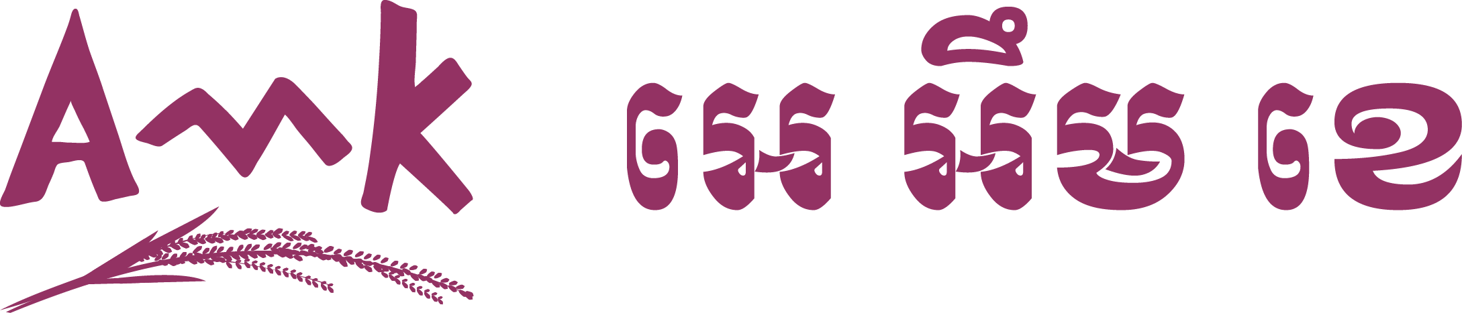­

Finance at your doorstep

**AMK Microfinance Institution Plc.** is one of Cambodia’s leading microfinance institutions, with coverage all over the country. AMK employs over 3,500 staff serving almost 1,000,000 clients in nearly 13,000 villages across Cambodia, 91% of all villages. We are looking for a talented and committed individual to join our diversified team, and offering attractive career prospects across branches and departments of our business.

A job at AMK is more than just a paycheck - we support our employees in their development and growth and help them explore their unique strengths.

**Job Title : Intern Technology Development Engineer**

**Report to : System Integration Manager**

**Location : Head office**

**Closing Date : July 10, 2020**

**Job Responsibilities**

General responsibilities is to lead the team to support the Technology System within AMK ‘s offices to meet the business requirement.

* Prototype product concepts
* Contribute ideas for new features and identify areas for improvement proactively
* To be proactive in responding to user issues and maintain “sense of urgency”.
* Assist software developer for designing and developing system as request from other department through MIS department head.
* Support, Maintain and Documentation the new and/or existing deployment system.

**Qualification and Experiences:**

* Studying in Computer Science or fresh graduated from a related field
* Experience developing web applications
* Experience of object-oriented software development
* Knowledge of desktop and mobile web browsers would be a plus
* Comfortable working through the entire stack from user interface through the systems levels
* Practical knowledge of Java programming with Spring Boot is a plus
* Experience working with Common DBMS such as SQL server, MySQL is a plus
* Experience with HTML, CSS, JSON, AJAX, C#, and JavaScript is a plus

AMK offer the opportunity to study and work directly with MIS Department, provide valuable experience, career development in the microfinance industry, 24hour accident insurance, and allowance.

Interested candidates should apply by sending a CV and a cover letter to: AMK branch and sub-branch offices or Head Office, Building 285, Yothapol Khemarak Phoumin Blvd. (271), Sk. Tomnub Tuek, Kh. Chamkarmorn, Phnom Penh, Cambodia or E-mail: [job@amkcambodia.com](mailto:job@amkcambodia.com)

Attachments:

A copy of obtained certificates or confirm letter by the University

A copy of national identification, family book, and certificate of birth

A copy of transcript is preferred.

For additional information, please contact at Tel: (023) 993 062 / (023) 224 763 or visiting website: [www.amkcambodia.com](http://www.amkcambodia.com)

AMK is an equal opportunity employment. Qualified women and disabled people are encouraged to apply.

Only short-listed candidates will be contacted for interview.